RF measurement and characterisation of European Spallation Source Cavities at UKRI-STFC Daresbury Laboratory and DESY
P.A. Smith*, Ayomikun Akintola, Keith Dumbell, Mike Ellis, Sean Hitchen, Philip Hornickel, Conor Jenkins, Geraint Jones, Michael Lowe, David Mason, Andrew J. May, Peter McIntosh, Keith Middleman, George Miller, Andrew Moss, Jennifer Mutch, Adrian Oates, Shrikant Pattalwar, Oliver Poynton, Paul A. Smith, Alan Wheelhouse, Stuart Wilde, James Wilson, A.E. Wheelhouse, UKRI-STFC Daresbury Laboratory, Keckwick Lane, Daresbury, WA4 4AD, UK
Lea Steder, Mateusz Wiencek, and Detlef Reschke
Deutsches Elektronen-Synchrotron DESY, Notkestr. 85, 22607 Hamburg, Germany

Abstract
The Accelerator and Science and Technology Centre (ASTeC) is responsible for delivering 88 High Beta (HB) cavities as part of the European Spallation Source (ESS) facility in Sweden. The bulk Niobium Superconducting Radio Frequency (SRF) cavities operate at 704 MHz. They have been fabricated in industry and are currently being tested at Daresbury Laboratory and Deutsches Elektronen-Synchrotron (DESY). They will then be delivered to Commissariat à l’énergie atomique et aux énergies alternatives (CEA) Saclay, France for integration into cryomodules. To date, 50 cavities have been conditioned and evaluated and 36 cavities have been delivered to CEA. This paper discusses the experiences and testing of the cavities performed to date at both sites.

Introduction
As part of the UK In-Kind-Contribution (IKC) to the European Spallation Source (ESS) facility in Sweden, STFC are providing 84 704 MHz high-beta superconducting RF cavities. These cavities are to be delivered to CEA-Saclay, France for integration into 21 cryomodules which will then be delivered to ESS. The cavities are required to have a quality factor (Qo) of 5 x 10⁹ at an accelerating gradient of 19.9 MV/m.

Table 1: ESS high-beta cavity parameters
Parameter | Value
Geometrical β | 0.86
Frequency (MHz) | 704.42
No. of cryomodules | 21
No. of cavities | 4
Cryomodule length (m) | 6.584
Nominal accelerating gradient (MV/m | 19.9
Nominal accelerating voltage (MV) | 18.2
Qo at nominal gradient | 5 x 10⁹

The test system used at STFC is quite different to most others used around the world. Cavities were tested horizontally, and cooled only by filling the LHe tanks [1] whereas most other systems use complete bath immersion. The other significant difference was that the radiation detectors at each end of the cavity were much closer. At STFC the detectors at each end were typically 25 to 30 cm from the ends of the cavities. This results in detection of radiation onset much earlier in the STFC system. A schematic of the STFC setup is presented in Figure 1. The detectors are at each end of the cavity, immediately outside the cryostat, but are not shown in the diagram.

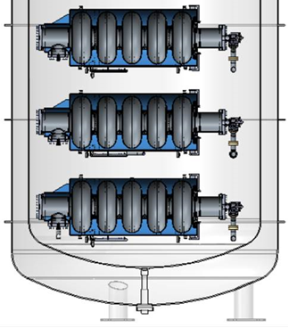
Figure 1 Schematic of STFC test system

Most other systems place the detectors 2 or 3m from the ends. A schematic of the test system at DESY [2] is shown in Figure 2. So the detectors at STFC are approximately 10 x closer. It was therefore expected, that the dose rate reading would be about 100x higher, from the simple 1/r² effect. At STFC there is also significantly less shielding material between the ends of the cavity and the detectors. Overall these two effects resulted in a dose rate reading at STFC that was approximately 300x larger than that measured at DESY.
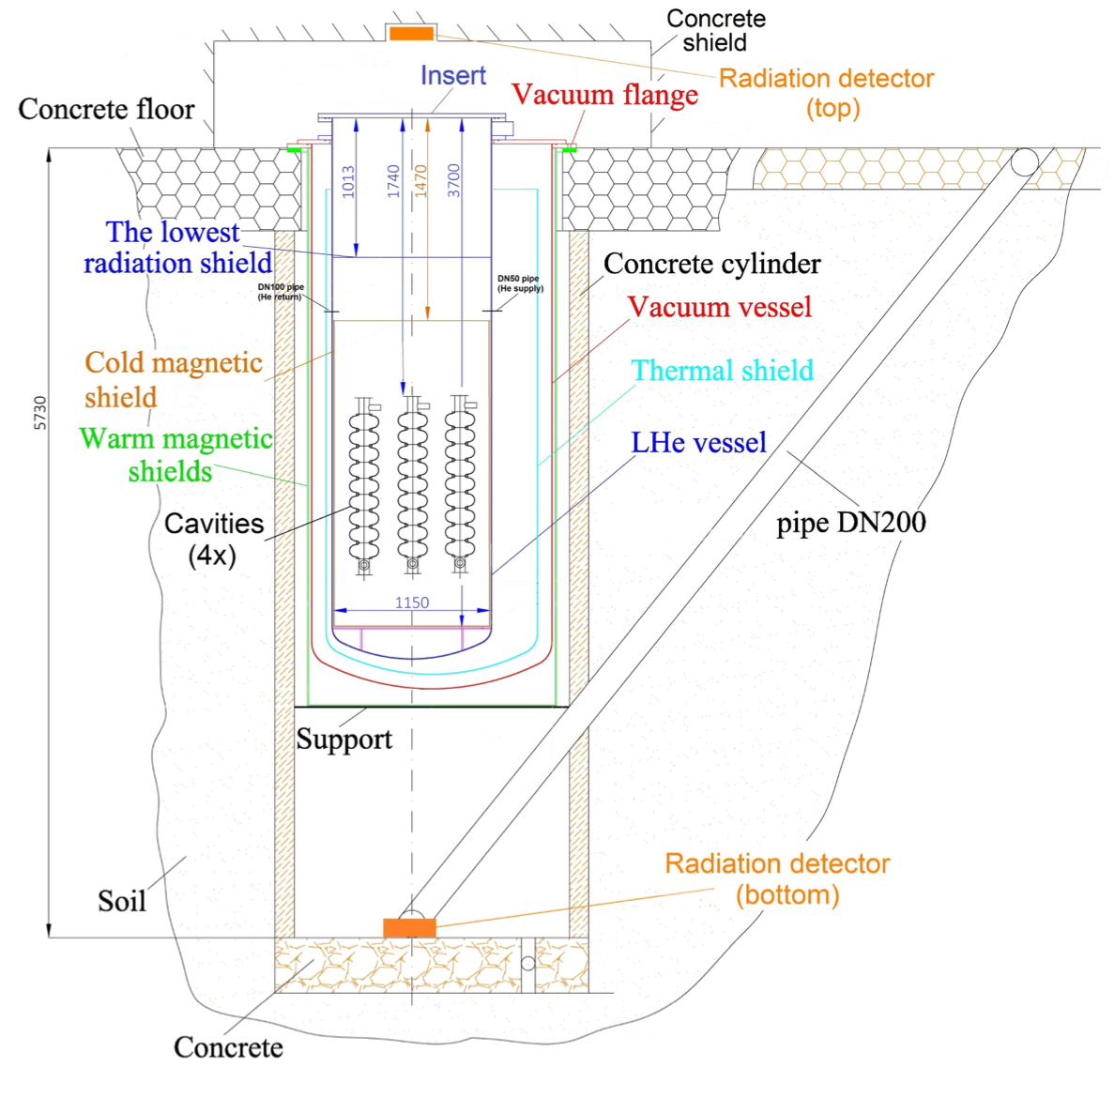
Figure 2 schematic of DESY test system

The ESS high-beta cavities have been fabricated by RI Research Instruments GmbH in Germany. All 88 cavities have been fabricated and delivered for testing.

CAVITY TESTING
Testing of the production cavities has been performed at both DESY and at STFC. However, the qualification of the pre-series cavities was conducted at DESY as it was not possible to test bare cavities at STFC. H001 to H004 were initially tested bare to verify the buffer chemical polishing (BCP) and high- pressure rinse (HPR) processes and were then retested again after the jackets had been added as shown in Figure 1. It was noted that H003 had an issue with a stain on the beam pipe which appeared to cause the radiation seen from an accelerating gradient of 16 MV/m. To verify the testing system at STFC H004 jacketed was tested at STFC. Results below, show an excellent correlation between the results obtained at DESY and STFC. Typically errors in E and Q, from run to run, are about 20% and 10% respectively [2] . The agreement between the results for H004, measured at both sites was well within this, and provides an excellent validation of the STFC measurement system. The repeatability of the results for H004, were also examined at STFC. This was done by making repeated measurements in the top, middle and bottom cradle positions. All of which showed good agreement within expected experimental error.

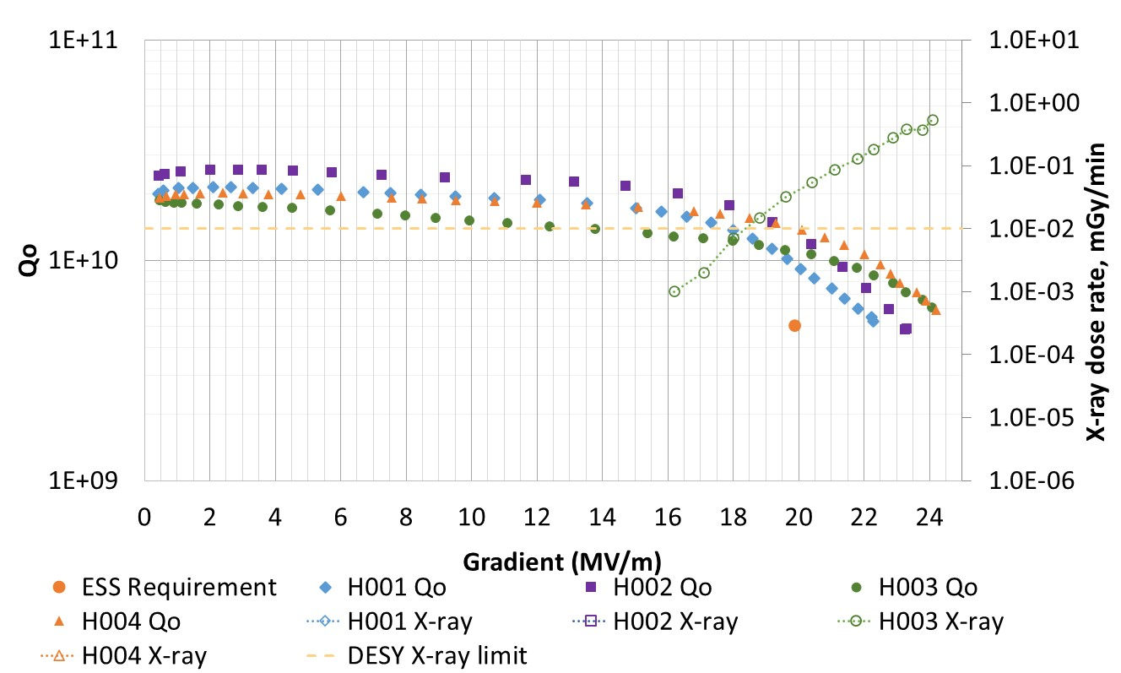Figure 3: H001 - H004 dressed cavity testing at DESY

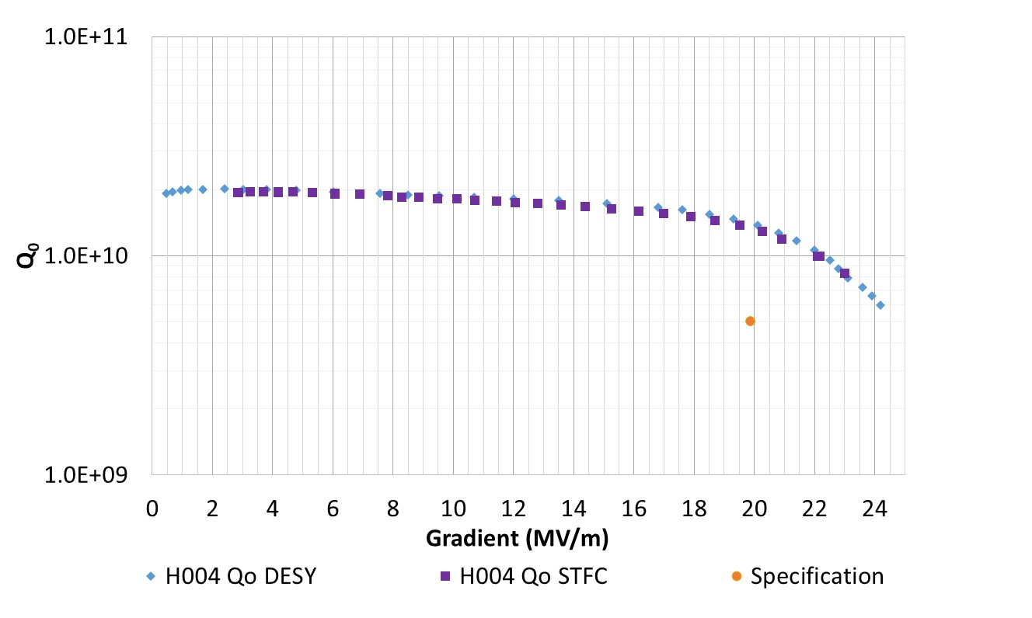

Figure 4: H004 cavity test results at DESY and STFC

Having established the process for the processing of the cavities at RI production cavities were commenced. However, the testing of cavities highlighted an issue with field emission (see Figure 5). A pass rate of only 28% was achieved for the first 18 cavities tested. The processes at RI were reviewed and several improvements were made, the main improvements were to double the final HPR from 12-hours to 24-hours and to include the installation of a Teflon disk on the bottom beampipe during coupler assembly so as to prevent the ingress of particulates. The pass rate of cavities increased to 67%. The test results for a sample number of cavities are shown in Figure 6. Due to the fact that the production rate from RI, was higher than initially could be tested at STFC, there were a number of cavities that had been delivered which had only received a 12-hour HPR. Thus a decision was made to return these to RI for an additional 24-hour HPR process. The first batch of these cavities has been received at STFC and are under-going testing. Initial results for these cavities tested to date at STFC have seen a reduction in the pass rate and this is currently under review.

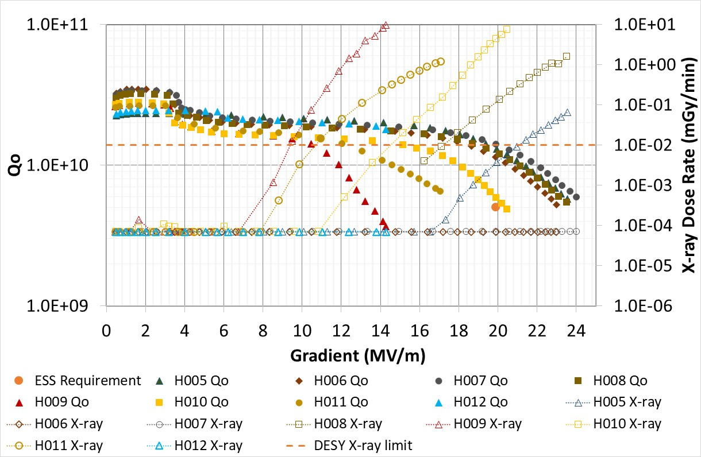
Figure 5: Production testing of cavities at DESY with a 12-hour HPR
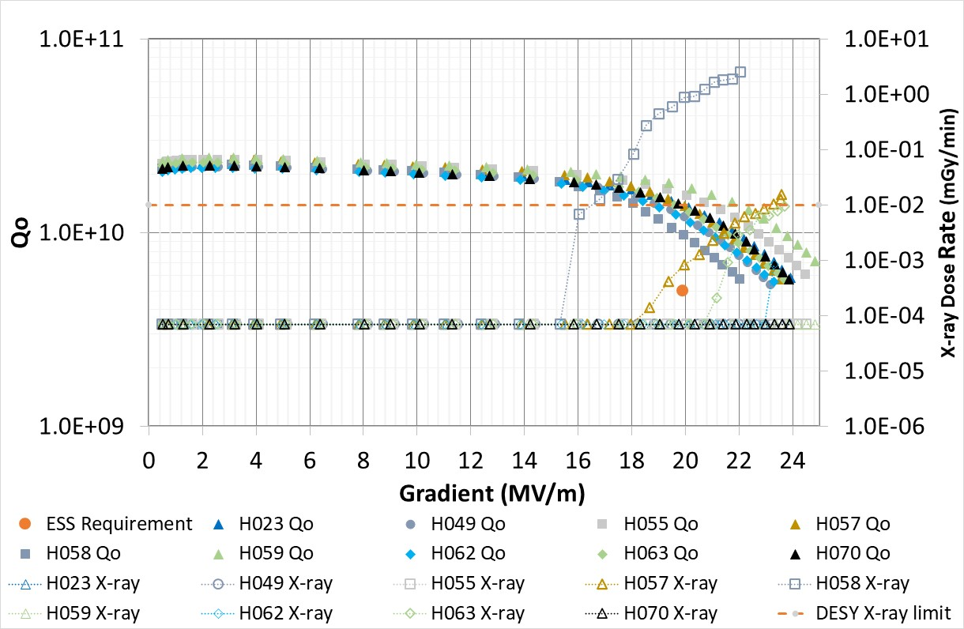

Figure 6: Production testing of cavities at DESY with a 24-hour HPR

Additionally, as H004 did not show signs of field emission, a cavity, H048, with field emission was tested at both STFC and DESY, so as to provide a comparison of radiation measured at both facilities. The results shown in Figure 7 highlight the fact that the STFC system has the ability to detect the onset of radiation at a much earlier stage and shows that at the operating gradient of 19.9 MV/m that there is a factor of approximately 300 difference between the measurements. Onset of radiation was detected at approximately 12 and 17 MV/m at STFC and DESY respectively.

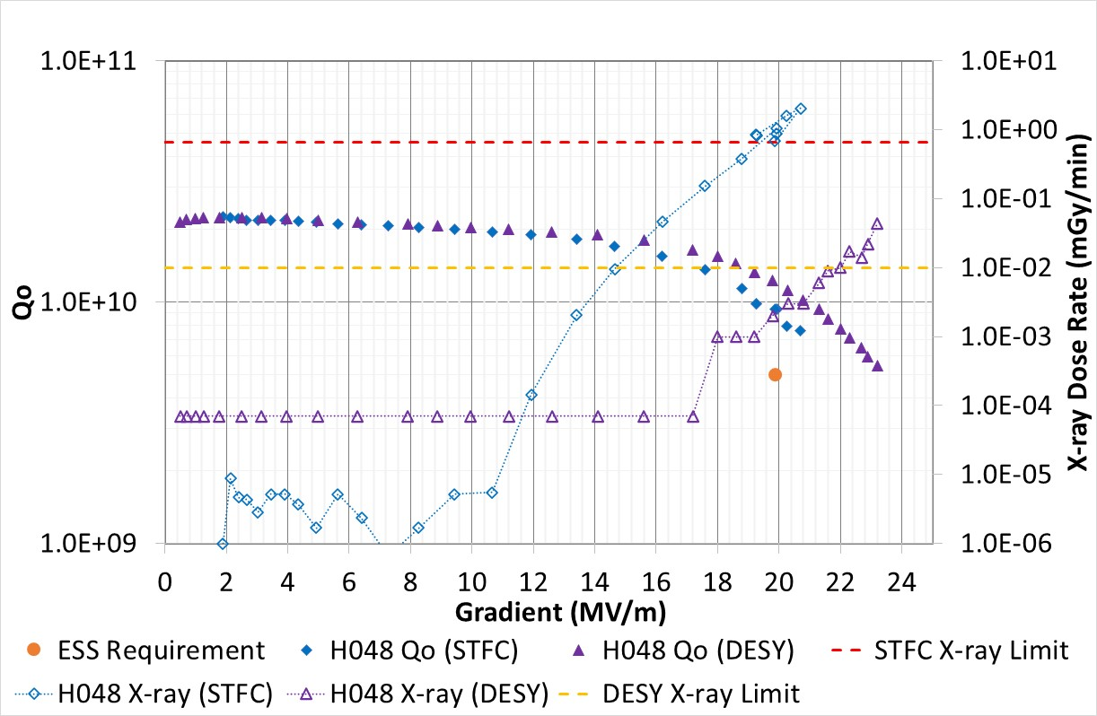
Figure 7: Radiation comparison of H048 at STFC and DESY

As part of the requirements for operation of the cavities at ESS the higher order modes (HOMs) are required to be more than ±5 MHz multiple of the machine line, 352.2 MHz. To date all cavities have successfully passed this requirement apart from H068, which had a 4th harmonic which was at 4.3 MHz from 1408.8MHz. Other authors have suggested that the HOM can be much closer than this to the 4th harmonic of the machine line, without causing any significant problems [3].Their work suggests that it can be as close as 5KHz before it causes significant problems to the operation of the accelerator.

SUMMARY AND FUTURE WORK
An RF test system has been developed and commissioned to enable the testing of ESS high-beta cavities. Testing of the cavities is currently well under way with a total of 50 cavities out of the 88 cavities fabricated having been tested at DESY and STFC. To date 36 cavities have been delivered to CEA for integration into cryomodules, of which 2 have already been fabricated. Issues have been encountered with field emission from cavities during testing. Improvements to the processing of the cavities within industry have yielded a much-improved first-time pass rate, however later cavities delivered have seen a dip in the yield. Further investigations are under way to look for improvements to the first-time pass rate.

ACKNOWLEDGEMENTS
The authors would like to thank collaborators from ESS, DESY, CEA, and INFN, as well as industrial partners. They also wouldke to thank T. Powers for his help in designing the test system as well as the use of the LabVIEW software from JLab. A. Matheisen for sharing technical knowledge for the design and commissioning of the SuRF Lab infrastructure. For administrative organisation, thanks to Mrs Soerne Moeller at DESY and Mr J Diakun at STFC.

References

[1] | A J May et al, “Commissioning and cryogenic performance of the UKRI-STFC Daresbury Vertical Test Facility for Jacketed SRF cavities,” in IOP Conf. Ser.: Mater. Sci. Eng. 1240 012079, 2022.
[2] | D. Reschke, “Performance in the vertical test of the 832 nine-cell 1.3 GHz cavities for the European X-ray Free Electron Laser,” Physical Review Accelerators and Beams, vol. 20, no. 4, pp. 042004-1 to 042004-30, 2017.
[3] | F. A, “Implications of Resonantly driven Higher Order Modes on the ESS Beam,” in Proceedings of the IPAC 2016 Busan Korea, Busan, 2016.

